Daniel Hannon 19484286

Console.java

/**
* Abstract class Console - write a description of the class here
*
* @author Daniel Hannon 19484286
* @version Final
*/
public abstract class Console {
// instance variables - replace the example below with your own
String name;
String description;
String color;
float price;

public Console(String name, String description, String color, float price) {
this.name = name;
this.description = description;
this.color = color;
this.price = price;
}

public String getName() {
return this.name;
}

public String getDescription() {
return this.description;
}

public String getColor() {
return this.color;
}

public float getCost() {
return this.price;
}
}

Tower_Console.java

/**
* Abstract class Tower_Console - write a description of the class here
*
* @author Daniel Hannon 19484286
* @version Final
*/
public abstract class Tower_Console extends Console
{
int generation;
boolean hasDiskDrive;
public Tower_Console(int generation, boolean hasDiskDrive, String name, String description, String color, float price) {
super(name, description, color, price);
this.generation = generation;
this.hasDiskDrive = hasDiskDrive;
}

public int getGeneration() {
return this.generation;
}

public boolean getHasDiskDrive() {
return this.hasDiskDrive;
}
}

Handheld_Console.java

/**
* Abstract class Handheld_Console - write a description of the class here
*
* @author (your name here)
* @version (version number or date here)
*/
public abstract class Handheld_Console extends Console
{
// instance variables - replace the example below with your own
float batteryLifeHours;
float weightGrams;

public Handheld_Console(float batteryLife, float weight, String name, String description, String color, float price) {
super(name, description, color, price);
this.batteryLifeHours = batteryLife;
this.weightGrams = weight;
}

public float getBatteryLifeHours() {
return this.batteryLifeHours;
}

public float getWeightGrams() {
return this.weightGrams;
}
}

Status.java

/**
* Write a description of interface Status here.
*
* @author Daniel Hannon
* @version Final
*/
public interface Status
{
public boolean getAvailability();
public void setAvailability(boolean isAvailable);
}

Xbox.java

/**
* Write a description of class Xbox here.
*
* @author Daniel Hannon 19484286
* @version Final
*/
public class Xbox extends Tower_Console implements Status
{
private String series;
private static boolean isAvailable;

public Xbox(String series, int generation, boolean hasDiskDrive, String description, String color, float price, boolean isAvailable) {
super(generation, hasDiskDrive, "Xbox", description, color, price);
this.series = series;
this.isAvailable = isAvailable;
}

public String getSeries(){
return this.series;
}

public boolean getAvailability() {
return this.isAvailable;
}

public void setAvailability(boolean isAvailable) {
this.isAvailable = isAvailable;
}

@Override
public String toString() {
String output = "";
output += "Name:\t\tMicrosoft Xbox Series " + series + "(Generation: "+ this.generation +")\n";
output += "Description:\t\t" + this.description + "\n";
output += "Disk Drive:\t\t";
if(this.hasDiskDrive) {
output+="Yes\n";
} else {
output+="No\n";
}
output+="Color:\t\t" + this.color + "\n";
output+="Price:\t\t" + (Math.round(this.price * 100.0f)/100.0f) +"\n";
output+="Available:\t\t";
if(this.isAvailable) {
output+="Yes\n";
} else {
output+="No\n";
}
return output;
}
}

Playstation.java

/**
* Write a description of class Playstation here.
*
* @author Daniel Hannon 19484286
* @version Final
*/
public class Playstation extends Tower_Console implements Status{
// instance variables - replace the example below with your ow
private String edition;
static boolean isAvailable;
/**
* Constructor for objects of class Playstation
*/
public Playstation(String edition, int generation, boolean hasDiskDrive, String description, String color, float price, boolean isAvailable)
{
// initialise instance variables
super(generation, hasDiskDrive, "Playstation", description, color, price);
this.edition = edition;
this.isAvailable = isAvailable;
}

public int getNumber() {
//They will always be the same
return this.generation;
}

public String getEdition() {
return this.edition;
}

public boolean getAvailability() {
return this.isAvailable;
}

public void setAvailability(boolean isAvailable) {
this.isAvailable = isAvailable;
}

@Override
public String toString() {
String output = "";
output += "Name:\t\tSony Playstation " + this.generation + "("+this.edition + " Edition)\n";
output += "Description:\t\t" + this.description + "\n";
output += "Disk Drive:\t\t";
if(this.hasDiskDrive) {
output+="Yes\n";
} else {
output+="No\n";
}
output+="Color:\t\t" + this.color + "\n";
output+="Price:\t\t" + (Math.round(this.price * 100.0f)/100.0f) +"\n";
output+="Available:\t\t";
if(this.isAvailable) {
output+="Yes\n";
} else {
output+="No\n";
}
return output;
}
}

Switch.java

/**
* Write a description of class Switch here.
*
* @author Daniel Hannon 19484286
* @version Final
*/
public class Switch extends Handheld_Console implements Status
{
private String model;
private static boolean isAvailable;
/**
* Constructor for objects of class Switch
*/
public Switch(String model, float batteryLife, float weight, String description, String color, float price, boolean isAvailable) {
super(batteryLife, weight, "Nintendo Switch", description, color, price);
this.model = model;
this.isAvailable = isAvailable;
}

public boolean getAvailability() {
return this.isAvailable;
}

public void setAvailability(boolean isAvailable) {
this.isAvailable = isAvailable;
}

@Override
public String toString() {
String output = "";
output += "Name:\t\tNintendo Switch (Model: "+this.model + ")\n";
output += "Description:\t\t" + this.description + "\n";
output += "Battery Life:\t\t" + (Math.round(this.batteryLifeHours * 100.0f)/100.0f) +" hours\n";
output += "Weight:\t\t" + (Math.round(this.weightGrams * 100.0f)/100.0f) + " grams\n";
output+="Color:\t\t" + this.color + "\n";
output+="Price:\t\t" + (Math.round(this.price * 100.0f)/100.0f) +"\n";
output+="Available:\t\t";
if(this.isAvailable) {
output+="Yes\n";
} else {
output+="No\n";
}
return output;
}
}

SmythsToyStore.java
import java.util.ArrayList;
/**
* Write a description of class SmythsToyStore here.
*
* @author Daniel Hannon
* @version Final
*/
public class SmythsToyStore {
public static void main(String[] args) {
Console myPlaystation = new Playstation("Digital",5,false,"Next Gen Console From Sony","White",400.00f,false);
Console myXbox = new Xbox("X",5,true,"Next Gen Console From Microsoft", "Black", 599.99f, false);
Console mySwitch = new Switch("Lite",9.0f,299.371f,"Next Gen Console from Nintendo", "Red", 339.99f, false);

int xboxCount = 0;
int playstationCount = 0;
int switchCount = 0;
ArrayList<Console> myList = new ArrayList<Console>();
for(int i = 0; i < 50; i++) {
myList.add(myPlaystation);
myList.add(myXbox);
myList.add(mySwitch);
}

for(int j = 0; j < 150; j++) {
Console temp = myList.get(j);
if (temp instanceof Playstation) {
playstationCount++;
if(playstationCount == 1) {
Playstation mytemp = (Playstation) temp;
mytemp.setAvailability(true);
}
} else if (temp instanceof Xbox) {
xboxCount++;
if(xboxCount == 1) {
Xbox tempxbox = (Xbox)temp;
tempxbox.setAvailability(true);

}
} else if (temp instanceof Switch) {
switchCount++;
if(switchCount == 1) {
Switch tempswitch = (Switch)temp;
tempswitch.setAvailability(true);
}
}
}

System.out.println("Total Ordered Consoles: " + (xboxCount + switchCount + playstationCount));
System.out.println("Total Order Cost: €" + (((float)xboxCount * myXbox.getCost()) +((float) switchCount * mySwitch.getCost()) + ((float)playstationCount * myPlaystation.getCost()))+"\n\n");
System.out.println("Xbox Consoles Ordered: " + xboxCount);
System.out.println("________XBOX________");
System.out.println(myXbox);
System.out.println("____________________");
System.out.println("Playstation Consoles Ordered: " + playstationCount);
System.out.println("________Playstation________");
System.out.println(myPlaystation);
System.out.println("____________________");
System.out.println("Switch Consoles Ordered: " + switchCount);
System.out.println("________Switch________");
System.out.println(mySwitch);
System.out.println("____________________");

}
}

OUTPUTS

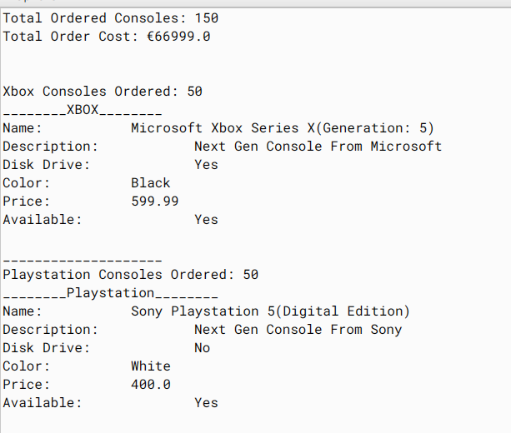
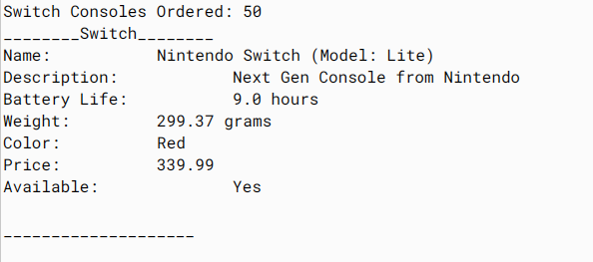
Hierarchy as in BlueJ

